**Activity:  How is interaction useful in visualization?  Think of at least two scenarios.**

1. click:  Allows user to “drill in” to a new graph
2. hover: allows user to maybe have a popover that comes up, or to highlight an area of the visualization

**Activity:  What do users intend to do using the following interaction techniques?  Do not use the names of the techniques in your answers.**

* Select: User intends to click on something to start an event
* Sort: User intends to order their list in a certain way
* Filter:  User wants a certain subset of the data
* Navigate:  User wants go to a certain area of a visual by scroll or click, or to get a different perspective
* Coordinate:  User wants to get something done typically on a time schedule

**Activity: Convert this interaction into a storyboard. (41 minutes into video)**

**Each frame is substantial.**

**Leaving it out alters the story.**

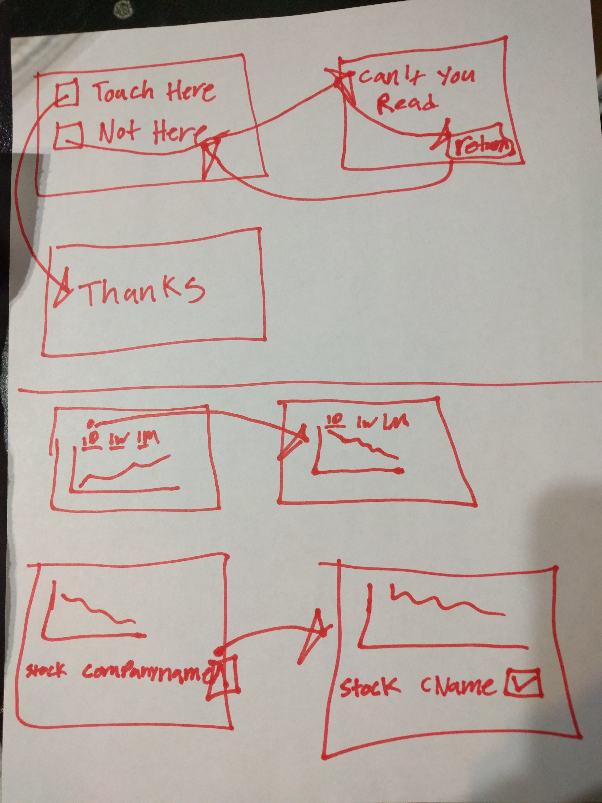

**Activity:  Datasets (49 minutes into the video)**

**What questions could you answer with this data and the visual encodings?  For each question create a branch in an interaction storyboard. (10 minutes)**

* Can we make the station/rating be more like an accordion so if we click the categories that it will move up the categories and show more categories?
* What about sub-categories for each category?

